Your Name Andrew Martin

**Cause/Effect Essay Topic Selection**

**Topic Selection Objectives:**

* To explore three different topics of your interest that you can possibly write a cause/effect essay about.
* To use the MHS library databases- SIRS and/or Global Issues in Context- to conduct your research.
* To take preliminary notes and write a summary that will help you narrow down your topic.

**Credible Sources:**

* It is vital that the information you learn be from a reliable source. Therefore, for this beginning stage, you are limited to using two of our library’s databases.

Locate the MHS library icon from the MHS toolbox and then select Research Help from the menu bar. Pick “English” from the drop-down menu. Then pick Cause/Effect Essays (it will automatically push you down the bottom of this page. Just scroll up to see the title.)

[](https://merrimackschooldistrict.sharepoint.com/sites/Student/SitePages/Home.aspx)



You will use SIRS and/or Global Issues for your topic selection. You will need to know the username/password.

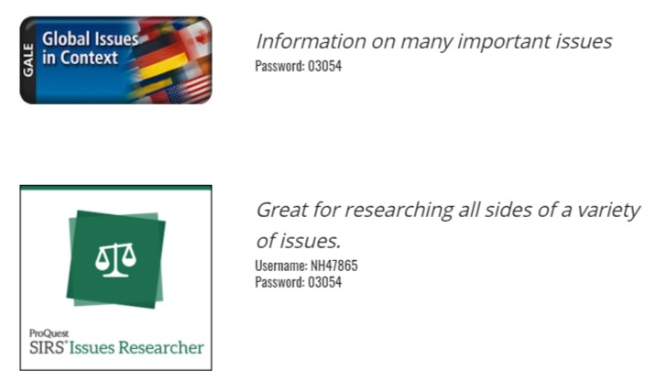

**You might look through the topic suggestions on the library reference page, too!**

**Topic Selection Research Directions:**

* As you explore, take notes on what you are learning in the “Notes Box”.
* Then provide a full sentence short summary of the issue at hand. Try to determine what causes and effects are associated with the topic and include that information in your summary of the issue.
* Provide a proper MLA citation for each article so you can locate it again. Use the cite button in the database to copy and paste the proper MLA citation.

Topic #1 Online Gaming Communities and mental health

Source: (highlight one) SIRS Global Issues in Context

Topic #1 Reading Notes:

* Though video game addiction can be seen as a negative mental health disorder, video games can improve mental health
  + Negative video game habits and video game addictions are caused when people are lacking basic needs and try to replace them with video games
* Scientists have measured reduction of stress and increase of self-worth procured from gaming
* Cooperative gaming has been proven to increase brain activity for younger people

Topic #1 Summary:

Video games, when used properly, can contribute to mental health, especially when played with a group.

Topic #1 article MLA Citation:

"The brain gain: why video games can make people happy." *Sydney Morning Herald* [Sydney, Australia], 9 Oct. 2013, p. 22. *Gale In Context: Global Issues*, link.gale.com/apps/doc/A345003075/GIC?u=nhais_401&sid=GIC&xid=0d11c73e. Accessed 7 Jan. 2021.

Topic #2 Global hyperconnectivity to the internet

Source: (highlight one) SIRS Global Issues in Context

Topic #2 Reading Notes:

* The internet has helped connect the globe in different ways
  + Economically
  + Culturally
  + Politically
* Censorship slows and distorts globalization
* Misinformation flows freely on the internet, with either too little control, or too much censorship.

Topic #2 Summary:

The internet has helped globalization, but it has also contributed to misinformation and censorship campaigns, allowing it to be used both as a tool and a weapon.

Topic #2 article MLA Citation:

"Internet and Globalization." *Gale Global Issues Online Collection*, Gale, 2020. *Gale In Context: Global Issues*,

link.gale.com/apps/doc/CP3208520205/GIC?u=nhais_401&sid=GIC&xid=29b44283. Accessed 6 Jan.

2021.

Topic #3 Eugenics to racism

Source: (highlight one) SIRS Global Issues in Context

Topic #3 Reading Notes:

* After slavery was abolished, eugenics took over as the top way of oppressing other races.
* Towards the end of the eugenics movement, races were redlined into low-value neighborhoods
  + This segregation caused the low value neighborhoods to decrease in value, indirectly forcing people into poverty.
* This segregation has still not been fully fixed, with many big cities still having “slums” where the redlined still live in poor conditions.
  + These poor conditions encourage behavior that fits the stereotype, which furthers racism in modern America.

Topic #3 Summary:

The eugenics movement from the early 1900s helped cause racism as it is today

Topic #3 article MLA Citation:

Lerner, Adrienne Wilmoth, and Joseph P. Hyder. "Ethnicity and Race." *Human Geography*: *People and the Environment*, edited by K. Lee Lerner, et al., vol. 1, Gale, 2013, pp. 196-200. *Gale In Context: Global Issues*, link.gale.com/apps/doc/CX2062300076/GIC?u=nhais_401&sid=GIC&xid=46e9295b. Accessed 7 Jan. 2021.